Supplementary Information
Physics-Aware Lightweight Segmentation for Quantitative Holographic Cell Analysis with Optical Mass Preservation
Usama Ikram¹, Youhyun Kim², and Inkyu Moon^{1,2,*}
¹Department of Artificial Intelligence, DGIST, Daegu 42988, South Korea
²Department of Robotics & Mechatronics Engineering, DGIST, Daegu 42988, South Korea

*Corresponding author: inkyu.moon@dgist.ac.kr (I. Moon)

S-I. Low-Rank Adaptation (LoRA) Rank Ablation for EdgeSAM
The effect of LoRA rank was systematically evaluated for EdgeSAM using r = 2, 4, 8, 16, and 32. As summarized in Table S-1, rank 8 provided the best overall balance, achieving the highest mean Dice (0.727), mean IoU (0.588), and Boundary F1 (0.952), together with an AJI of 0.484. The integrated-phase error (IPE) also decreased substantially from 8.62% at r = 2 to 3.63% at r = 8. Although r = 32 achieved a slightly lower IPE of 3.45%, it required 1.47 M trainable parameters compared with only 0.53 M at r = 8 and reduced the AJI to 0.372. As illustrated in Fig. S-1, increasing the LoRA rank beyond 8 substantially increased the number of trainable parameters without providing a corresponding improvement in segmentation accuracy. Inference latency and peak VRAM usage also remained nearly unchanged across the rank sweep, indicating that LoRA rank primarily affects adaptation capacity and parameter efficiency rather than inference cost. Considering segmentation accuracy, instance separation, integrated-phase preservation, and trainable parameter efficiency together, r = 8 was selected as the optimal LoRA rank for EdgeSAM and used in the subsequent analyses.
TABLE S-1
LoRA rank ablation for EdgeSAM. The shaded row indicates the selected configuration. Rank 8 provides the best balance of segmentation accuracy, instance separation, integrated-phase preservation, and parameter efficiency. Latency and peak VRAM were measured using native PyTorch FP32 on an NVIDIA RTX A5000.
Rank (r) | Trainable | Mean Dice ↑ | Mean IoU ↑ | AJI ↑ | Boundary F1 ↑ | IPE (%) ↓ | $p_{50}$ (ms) / VRAM (MB)
2 | 0.30M (5.20%) | 0.633 | 0.482 | 0.465 | 0.905 | 8.62 | 15.54 / 177.3
4 | 0.38M (6.46%) | 0.638 | 0.490 | 0.405 | 0.918 | 5.53 | 15.33 / 177.9
8 | 0.53M (8.90%) | 0.727 | 0.588 | 0.484 | 0.952 | 3.63 | 13.36 / 177.9
16 | 0.85M (13.40%) | 0.676 | 0.533 | 0.420 | 0.946 | 3.86 | 13.32 / 177.9
32 | 1.47M (21.19%) | 0.710 | 0.567 | 0.372 | 0.950 | 3.45 | 13.25 / 177.9
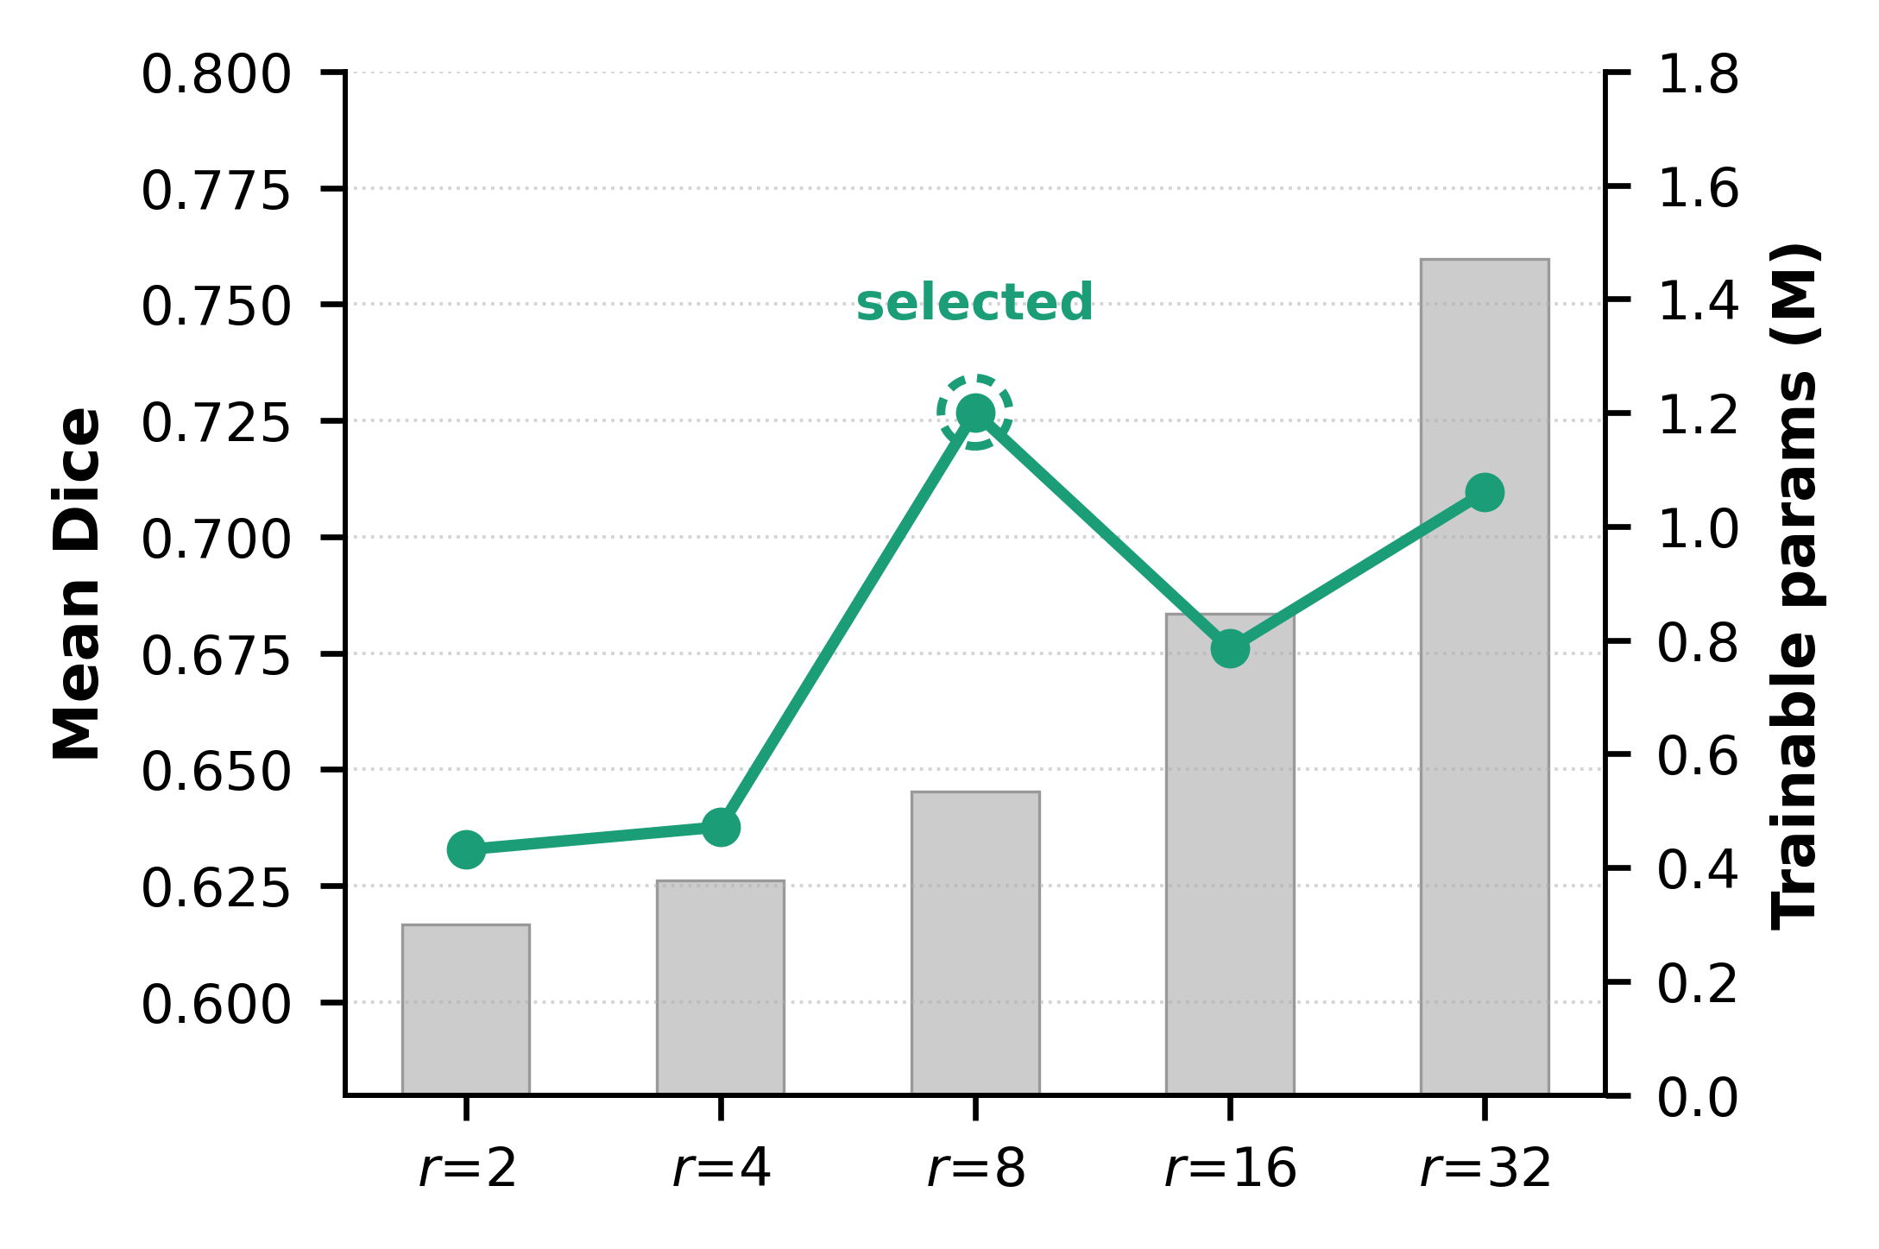
Fig. S-1. Effect of LoRA rank on EdgeSAM mean Dice (line) and trainable parameters (bars).
S-II. Accuracy-Efficiency Trade-off
Fig. S-2 summarizes the overall trade-off among segmentation accuracy, instance separation, boundary fidelity, throughput, and memory efficiency for the three architectures. Although MobileNet-UNet occupies a large area in the radar representation because of its high aggregate Boundary F1 and AJI, the plot does not explicitly represent morphology-class coverage. Its apparent advantage in these aggregate metrics must therefore be interpreted together with the complete segmentation failure observed for echinocytes and stomatocytes in Fig. 3 of the main text.
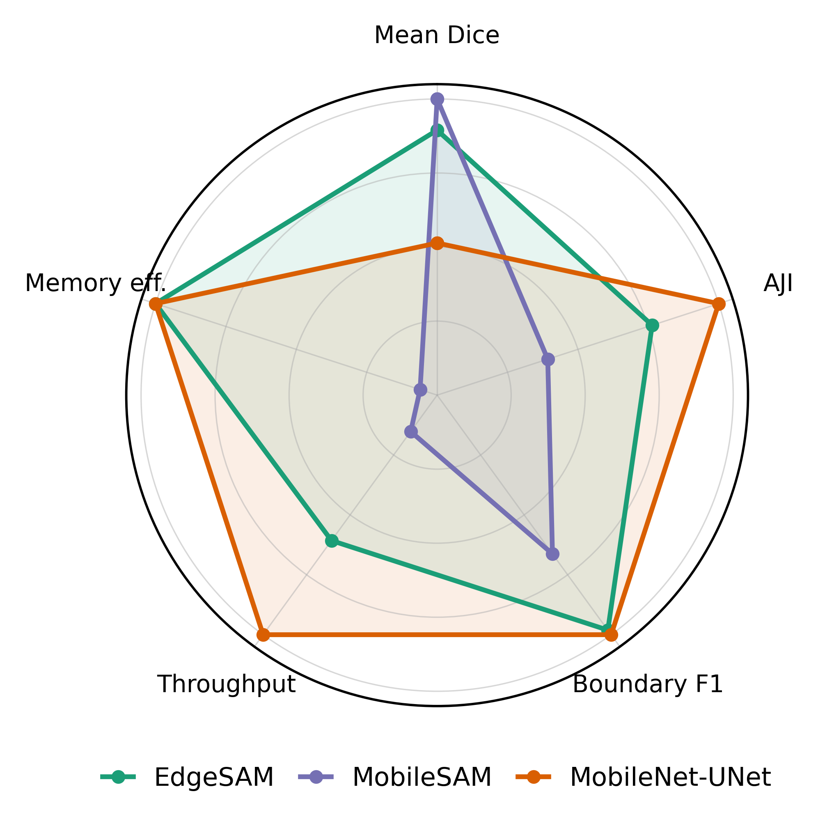
Fig. S-2. Aggregate performance at LoRA rank r = 8, each axis normalized to the best model. Per-class coverage is not encoded; see Fig. 3 of the main text.
Fig. S-3 compares the three architectures in terms of segmentation accuracy and computational throughput. Each architecture is represented using its native PyTorch and, where available, ONNX Runtime implementations. MobileSAM achieved the highest mean Dice but exhibited the lowest throughput and could not be reliably accelerated using ONNX Runtime because of unsupported operations in its cross-attention mask decoder. MobileNet-UNet achieved the highest computational throughput but suffered complete failure for two minority morphology classes. Its computational advantage therefore does not translate into reliable quantitative multi-class RBC analysis. EdgeSAM occupied the most favorable region of the accuracy-efficiency trade-off. ONNX FP16 execution substantially increased throughput while preserving detection of all four RBC morphologies and maintaining a mean Dice of 0.727. It also required a smaller trainable parameter footprint than the other evaluated architectures. Accordingly, among models satisfying the fundamental requirement of non-degenerate multi-class segmentation, EdgeSAM provided the most favorable balance among segmentation performance, quantitative measurement capability, and computational efficiency. Importantly, these results characterize GPU-based computational efficiency rather than actual embedded-device deployment. They nevertheless demonstrate that the selected architecture has computational characteristics favorable for future implementation in resource-constrained holographic imaging systems.

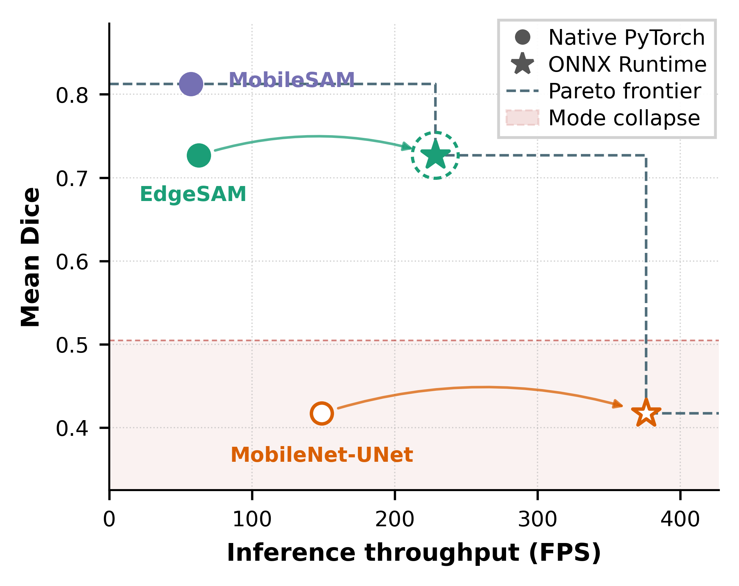
Fig. S-3. Accuracy-throughput frontier at LoRA rank r = 8, FP16. Arrows join the native PyTorch and ONNX Runtime points of one architecture; the dashed ring marks the selected configuration.
S-III. Boundary Quality and Physical Gradient Alignment
Accurate boundary localization is particularly important in quantitative phase imaging (QPI) because dilation or erosion of the predicted cellular region directly affects the integrated phase used for subsequent quantitative analysis. The boundary-gradient alignment (BGA) term addresses this issue by encouraging predicted cell boundaries to follow spatial phase transitions in the quantitative phase map. As illustrated in Fig. S-4, EdgeSAM predictions show clear spatial correspondence with strong phase-gradient structures near cellular boundaries. The contribution of BGA is further supported by the loss ablation in Section 4.3 of the main text, where adding BGA to the phase-mask contrast (PMC) configuration substantially restored boundary fidelity. Moreover, as summarized in Table S-1, EdgeSAM maintained high Boundary F1 scores at ranks of 8 and above, ranging from 0.946 to 0.952, whereas the two smallest ranks gave lower values (0.905 at r = 2 and 0.918 at r = 4), indicating that boundary localization remained accurate once the adaptation capacity reached r = 8. Together, these results demonstrate that phase-gradient information provides an effective physical cue for cellular boundary localization, while the high Boundary F1 at ranks of 8 and above supports the robustness of the proposed lightweight segmentation framework.
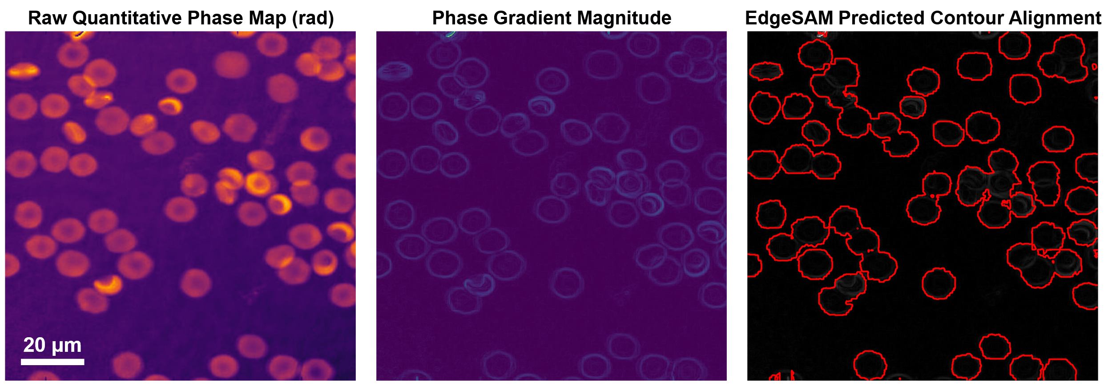
Fig. S-4. Alignment of predicted cell contours with quantitative phase gradients. Left: quantitative phase map. Center: phase-gradient magnitude. Right: EdgeSAM (r = 8) contours overlaid on the phase-gradient map, showing their spatial correspondence with phase-gradient structures.
S-IV. Representative Quantitative Phase Images over the Storage Period
Fig. S-5 shows representative quantitative phase images from different points of the 47-day storage period. Cells at the earliest time point are mostly biconcave discocytes, while images from later storage show a growing share of cells with altered shapes.

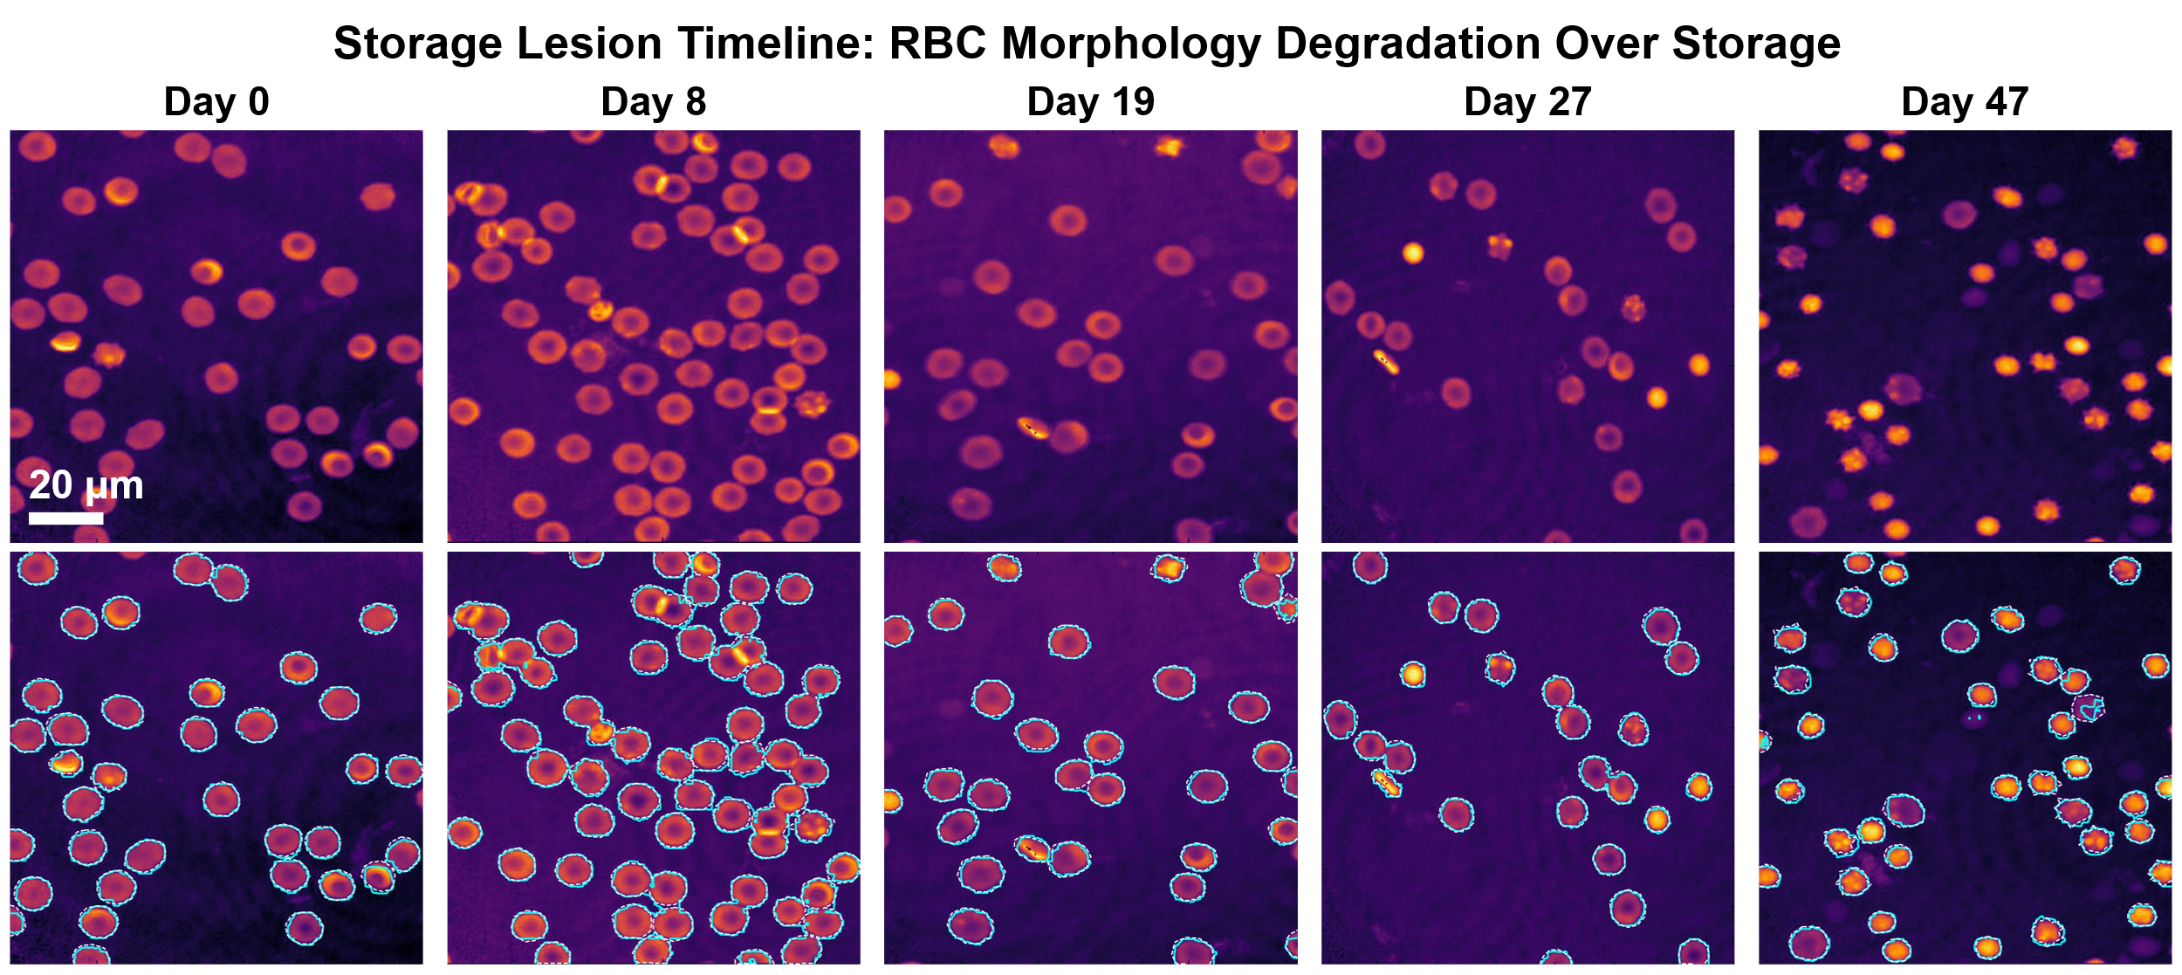
Fig. S-5. Representative quantitative phase images illustrating RBC morphological changes associated with storage lesion over the 47-day storage period.

